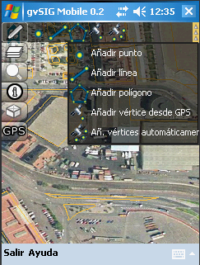
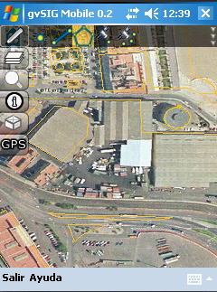
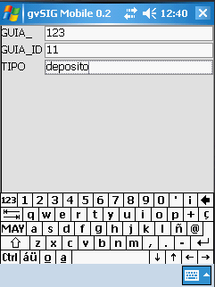
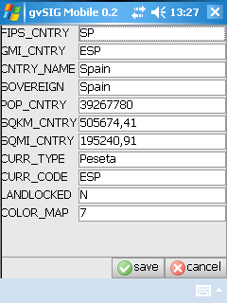
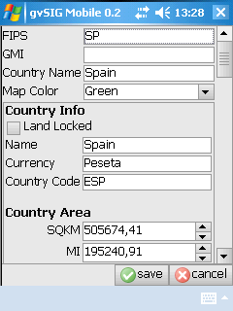
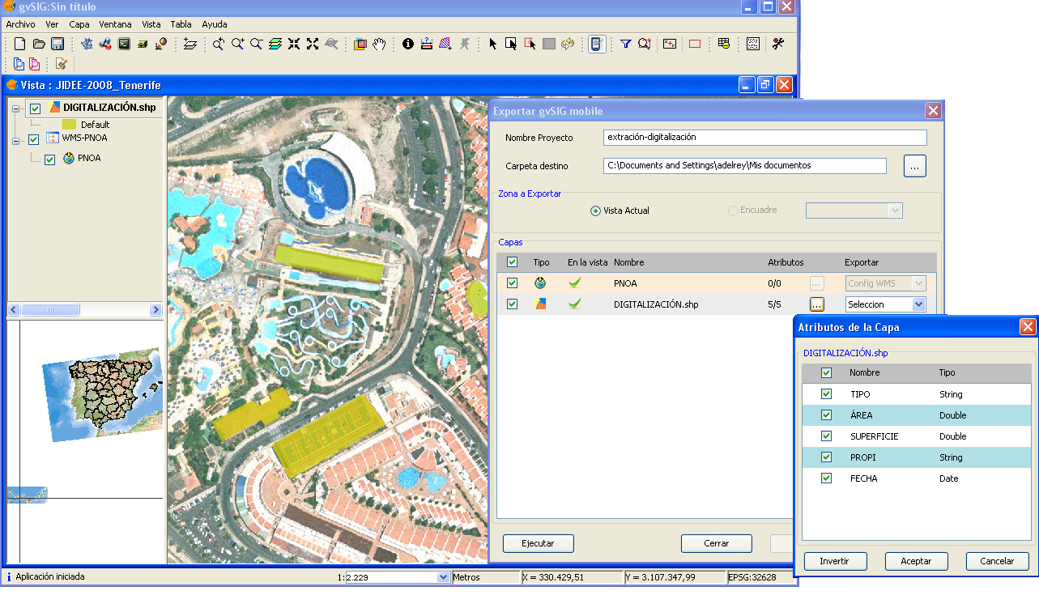
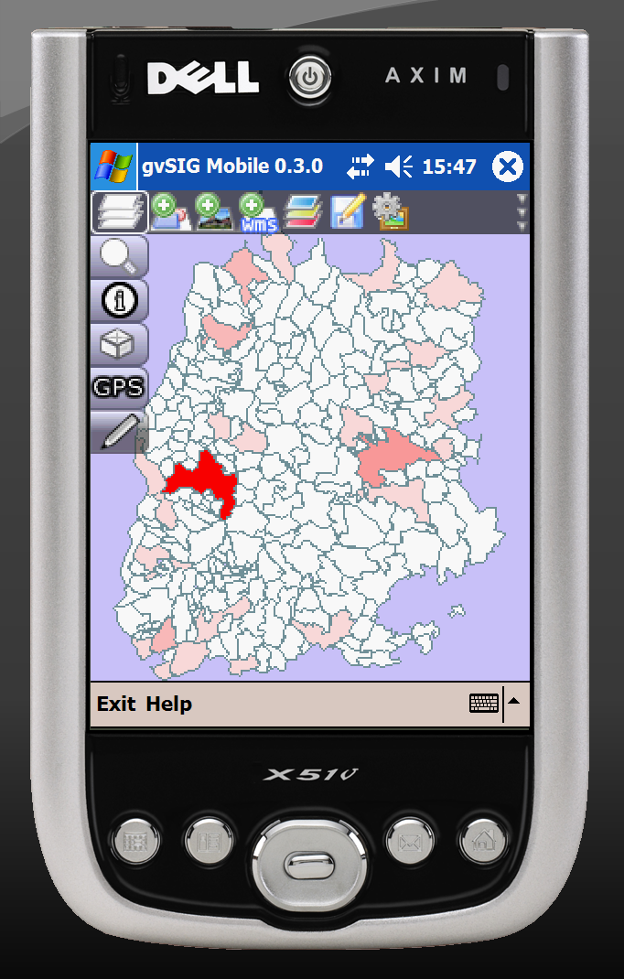
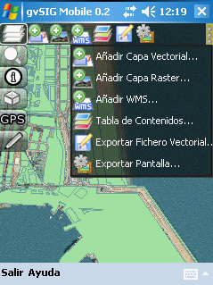
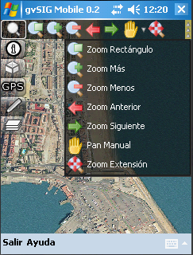
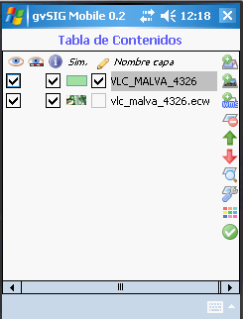
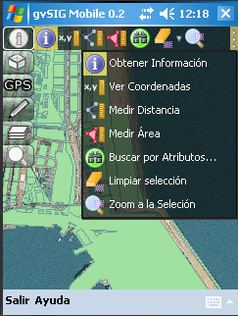
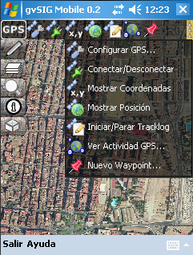



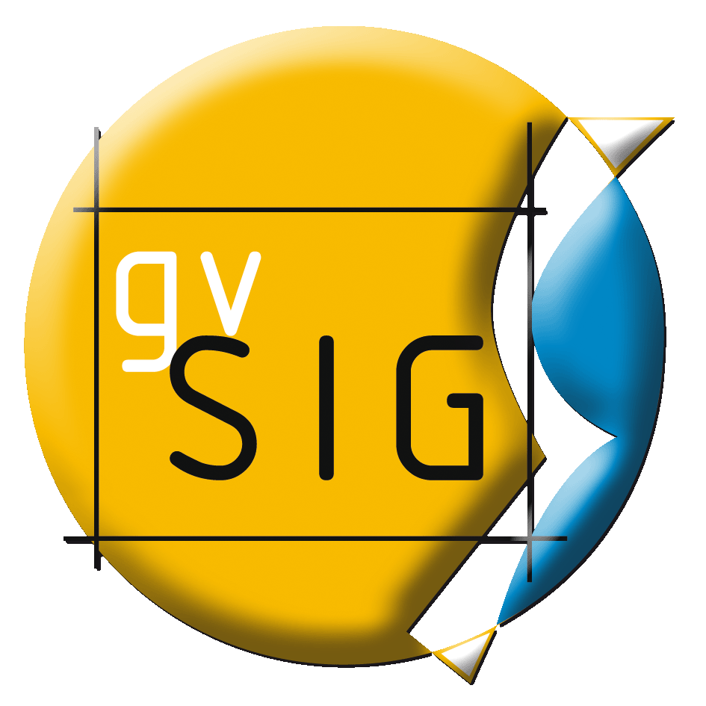
gvSIG Mobile

Main characteristics

- Development language: Java
- Available for platforms supporting Java ME (J2ME – CDC): Windows Mobile 5.0 and 6.0
- OGC Standars
- Free license (GNU/GPL).
- Modular, scalable, powerful.
- Simple interface: user friendly.
- Available in more than 10 languages.

http://www.gvsig.org
http://www.gvsig.com

gvSIG Mobile is a Geographic Information System (GIS) aimed at mobile devices, ideal for projects that capture and update data in the field. It's known for having a user-friendly interface, being able to access the most common formats and a wide range of GIS and GPS tools which are ideal for working with geographic information.
So far, gvSIG Mobile is a Geographic Information System, as well as a Spatial Data Infrastructures client for mobile devices.
Features: Access to vector (SHP, GML, KML, GPX) and raster formats (ECW, JPEG, PNG, GIF); Access to remote services (OGC WMS); Display; Query; Selection; Search; GPS; Graphic and Alphanumeric editing; Vector representation; Tables; Data portability and data integration with gvSIG Desktop.
Navigation
Add Data
Query Data
Layer management
GPS Support
Editing of data
Use of custom forms

Data integration: gvSIG extension to export data to the PDA

- OGC Services: WFS
- Thematic symbology: range and unique values
- Labelling
- Advanced editing of vector data
- Table structure modifications
- Advanced GPS Location
- LandMarkStores Management
- OSGi extensibility

GML,KML and GPX formats support
Range value thematics maps
gvSIG Mobile 1.0

